A **Context** is a handle to the system; it provides services like resolving resources, obtaining access to databases and preferences, and so on. An **Android**app has activities. **Context** is like a handle to the environment your application is currently running in. The activity object inherits the **Context** object.

An **Android Toast** is a small message displayed on the screen, similar to a tool tip or other similar popup notification. A **Toast** is displayed on top of the main content of an activity, and only remains visible for a short time period

The core building blocks or **fundamental components of android** are activities, views, intents, services, content providers, fragments and AndroidManifest.xml.

An **Intent** is a simple message object that is used to communicate between **android** components such as activities, content providers, broadcast receivers and services. **Intents** are also used to transfer data between activities. **Intents** are generally used for starting a new activity using startActivity()

Data soft

How to swap two numbers without using a temporary variable?

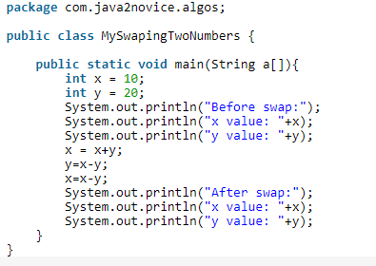

[printing fibonacci number series without using loops](https://stackoverflow.com/questions/7985470/printing-fibonacci-number-series-without-using-loops)

Write a program to find top two maximum numbers in a array.

